Министерство образования и науки Российской Федерации

Новосибирский государственный технический университет

Кафедра прикладной математики

Уравнения математической физики

Лабораторная работа №1

Факультет ПМИ

Группа ПМ-01

Студент Жигалов П.С.

Преподаватель Задорожный А.Г.

Персова М.Г.

Вариант 7

Новосибирск

2013

**1. Цель работы**

Разработать программу решения эллиптической краевой задачи методом конечных разностей. Протестировать программу и численно оценить порядок аппроксимации.

**2. Задание**

Уравнение: (1) для функции , краевые условия: (2), (3).

Область  имеет Г-образную форму

**3. Анализ**

Для двумерного оператора Лапласа  дискретный аналог, аппроксимирующий вторые производные на неравномерной прямоугольной сетке, может быть определен пятиточечным разностным выражением:

 (4).

Подставив (4) в (1), получим:

 (5).

Введем одноиндексную нумерацию узлов сетки в соответствии с рисунком. Для вычисления номера узла будем использовать формулу .

Таким образом, уравнение (5) примет вид:

 (6).

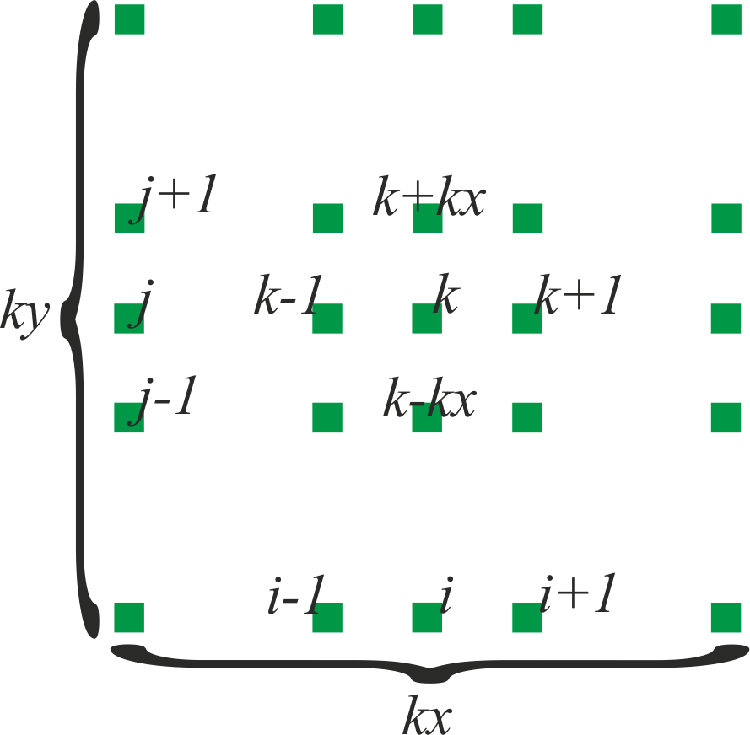Учет краевых условий второго рода (3) будем учитывать следующим образом. Так как расчетная область представляет собой прямоугольник со сторонами, параллельными координатным осям, то направление нормали к границе , на которой заданы краевые условия второго рода, совпадает с одной из координатных линий, и тогда аппроксимация производной по нормали (которая в этом случае будет равна либо , либо ) сводится к одномерным разностям первого порядка:  (7) и  (8).

**4. Способ хранения матрицы и метод решения СЛАУ**

Матрицу будем хранить в пятидиагональном формате. Из-за особенностей области  крайние верхняя и нижняя диагонали не будут непрерывными, а будут совершать скачок, симметричный относительно главной диагонали. Эту особенность необходимо учитывать при решении СЛАУ.

Для решения СЛАУ будем использовать метод Гаусса-Зейделя с параметром релаксации.

**5. Тесты**

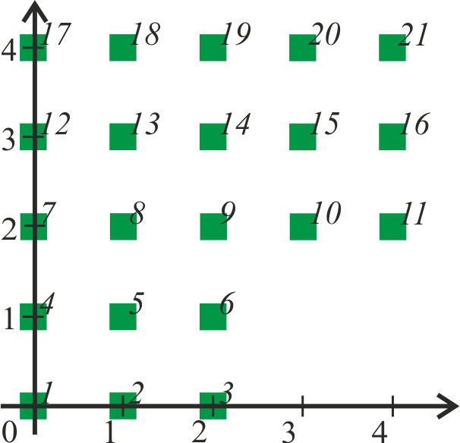***1). Простейший тест***

Искомая функция: 

Уравнение: 

Краевые условия: первого рода на всех ребрах.

|  |  |  |  |  |
| --- | --- | --- | --- | --- |
| **x** | **y** | **u** | **u\*** | **|u*-u|** |
| 0.00 | 0.00 | 0.0000000000000000E+00 | 0.0000000000000000E+00 | 0.000E+00 |
| 1.00 | 0.00 | 1.0000000000000000E+00 | 1.0000000000000000E+00 | 0.000E+00 |
| 2.00 | 0.00 | 2.0000000000000000E+00 | 2.0000000000000000E+00 | 0.000E+00 |
| 0.00 | 1.00 | 1.0000000000000000E+00 | 1.0000000000000000E+00 | 0.000E+00 |
| 1.00 | 1.00 | 2.0000000000000000E+00 | 2.0000000000000000E+00 | 0.000E+00 |
| 2.00 | 1.00 | 3.0000000000000000E+00 | 3.0000000000000000E+00 | 0.000E+00 |
| 0.00 | 2.00 | 2.0000000000000000E+00 | 2.0000000000000000E+00 | 0.000E+00 |
| 1.00 | 2.00 | 3.0000000000000000E+00 | 3.0000000000000000E+00 | 0.000E+00 |
| 2.00 | 2.00 | 4.0000000000000000E+00 | 4.0000000000000000E+00 | 0.000E+00 |
| 3.00 | 2.00 | 5.0000000000000000E+00 | 5.0000000000000000E+00 | 0.000E+00 |
| 4.00 | 2.00 | 6.0000000000000000E+00 | 6.0000000000000000E+00 | 0.000E+00 |
| 0.00 | 3.00 | 3.0000000000000000E+00 | 3.0000000000000000E+00 | 0.000E+00 |
| 1.00 | 3.00 | 4.0000000000000000E+00 | 4.0000000000000000E+00 | 0.000E+00 |
| 2.00 | 3.00 | 5.0000000000000000E+00 | 5.0000000000000000E+00 | 0.000E+00 |
| 3.00 | 3.00 | 6.0000000000000000E+00 | 6.0000000000000000E+00 | 0.000E+00 |
| 4.00 | 3.00 | 7.0000000000000000E+00 | 7.0000000000000000E+00 | 0.000E+00 |
| 0.00 | 4.00 | 4.0000000000000000E+00 | 4.0000000000000000E+00 | 0.000E+00 |
| 1.00 | 4.00 | 5.0000000000000000E+00 | 5.0000000000000000E+00 | 0.000E+00 |
| 2.00 | 4.00 | 6.0000000000000000E+00 | 6.0000000000000000E+00 | 0.000E+00 |
| 3.00 | 4.00 | 7.0000000000000000E+00 | 7.0000000000000000E+00 | 0.000E+00 |
| 4.00 | 4.00 | 8.0000000000000000E+00 | 8.0000000000000000E+00 | 0.000E+00 |

= 0.000E+00

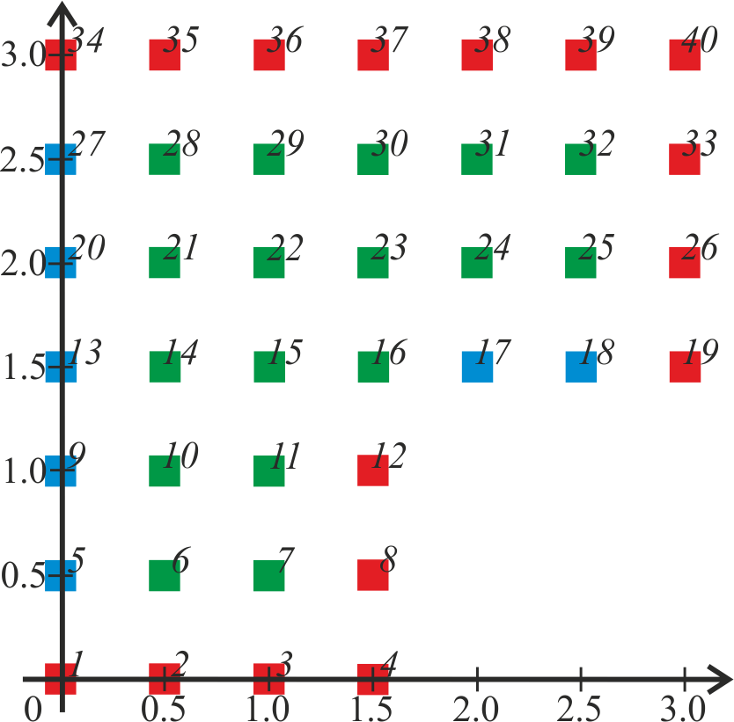***2) Тест на краевые условия второго рода***

Искомая функция: 

Уравнение: 

Краевые условия: второго рода (синим цветом), первого рода (красным).

|  |  |  |  |  |
| --- | --- | --- | --- | --- |
| **x** | **y** | **u** | **u\*** | **|u*-u|** |
| 0.00 | 0.00 | 0.0000000000000000E+00 | 0.0000000000000000E+00 | 0.000E+00 |
| 0.50 | 0.00 | 5.0000000000000000E-01 | 5.0000000000000000E-01 | 0.000E+00 |
| 1.00 | 0.00 | 1.0000000000000000E+00 | 1.0000000000000000E+00 | 0.000E+00 |
| 1.50 | 0.00 | 1.5000000000000000E+00 | 1.5000000000000000E+00 | 0.000E+00 |
| 0.00 | 0.50 | 4.9999999999999800E-01 | 5.0000000000000000E-01 | 1.998E-15 |
| 0.50 | 0.50 | 9.9999999999999900E-01 | 1.0000000000000000E+00 | 9.992E-16 |
| 1.00 | 0.50 | 1.5000000000000000E+00 | 1.5000000000000000E+00 | 0.000E+00 |
| 1.50 | 0.50 | 2.0000000000000000E+00 | 2.0000000000000000E+00 | 0.000E+00 |
| 0.00 | 1.00 | 9.9999999999999800E-01 | 1.0000000000000000E+00 | 1.998E-15 |
| 0.50 | 1.00 | 1.4999999999999900E+00 | 1.5000000000000000E+00 | 9.992E-15 |
| 1.00 | 1.00 | 1.9999999999999900E+00 | 2.0000000000000000E+00 | 9.992E-15 |
| 1.50 | 1.00 | 2.5000000000000000E+00 | 2.5000000000000000E+00 | 0.000E+00 |
| 0.00 | 1.50 | 1.4999999999999900E+00 | 1.5000000000000000E+00 | 9.992E-15 |
| 0.50 | 1.50 | 1.9999999999999900E+00 | 2.0000000000000000E+00 | 9.992E-15 |
| 1.00 | 1.50 | 2.4999999999999900E+00 | 2.5000000000000000E+00 | 1.021E-14 |
| 1.50 | 1.50 | 2.9999999999999900E+00 | 3.0000000000000000E+00 | 1.021E-14 |
| 2.00 | 1.50 | 3.5000000000000000E+00 | 3.5000000000000000E+00 | 0.000E+00 |
| 2.50 | 1.50 | 4.0000000000000000E+00 | 4.0000000000000000E+00 | 0.000E+00 |
| 3.00 | 1.50 | 4.5000000000000000E+00 | 4.5000000000000000E+00 | 0.000E+00 |
| 0.00 | 2.00 | 1.9999999999999900E+00 | 2.0000000000000000E+00 | 9.992E-15 |
| 0.50 | 2.00 | 2.4999999999999900E+00 | 2.5000000000000000E+00 | 1.021E-14 |
| 1.00 | 2.00 | 2.9999999999999900E+00 | 3.0000000000000000E+00 | 1.021E-14 |
| 1.50 | 2.00 | 3.4999999999999900E+00 | 3.5000000000000000E+00 | 1.021E-14 |
| 2.00 | 2.00 | 4.0000000000000000E+00 | 4.0000000000000000E+00 | 0.000E+00 |
| 2.50 | 2.00 | 4.5000000000000000E+00 | 4.5000000000000000E+00 | 0.000E+00 |
| 3.00 | 2.00 | 5.0000000000000000E+00 | 5.0000000000000000E+00 | 0.000E+00 |
| 0.00 | 2.50 | 2.4999999999999900E+00 | 2.5000000000000000E+00 | 1.021E-14 |
| 0.50 | 2.50 | 2.9999999999999900E+00 | 3.0000000000000000E+00 | 1.021E-14 |
| 1.00 | 2.50 | 3.4999999999999900E+00 | 3.5000000000000000E+00 | 1.021E-14 |
| 1.50 | 2.50 | 4.0000000000000000E+00 | 4.0000000000000000E+00 | 0.000E+00 |
| 2.00 | 2.50 | 4.5000000000000000E+00 | 4.5000000000000000E+00 | 0.000E+00 |
| 2.50 | 2.50 | 5.0000000000000000E+00 | 5.0000000000000000E+00 | 0.000E+00 |
| 3.00 | 2.50 | 5.5000000000000000E+00 | 5.5000000000000000E+00 | 0.000E+00 |
| 0.00 | 3.00 | 3.0000000000000000E+00 | 3.0000000000000000E+00 | 0.000E+00 |
| 0.50 | 3.00 | 3.5000000000000000E+00 | 3.5000000000000000E+00 | 0.000E+00 |
| 1.00 | 3.00 | 4.0000000000000000E+00 | 4.0000000000000000E+00 | 0.000E+00 |
| 1.50 | 3.00 | 4.5000000000000000E+00 | 4.5000000000000000E+00 | 0.000E+00 |
| 2.00 | 3.00 | 5.0000000000000000E+00 | 5.0000000000000000E+00 | 0.000E+00 |
| 2.50 | 3.00 | 5.5000000000000000E+00 | 5.5000000000000000E+00 | 0.000E+00 |
| 3.00 | 3.00 | 6.0000000000000000E+00 | 6.0000000000000000E+00 | 0.000E+00 |

= 1.718E-15

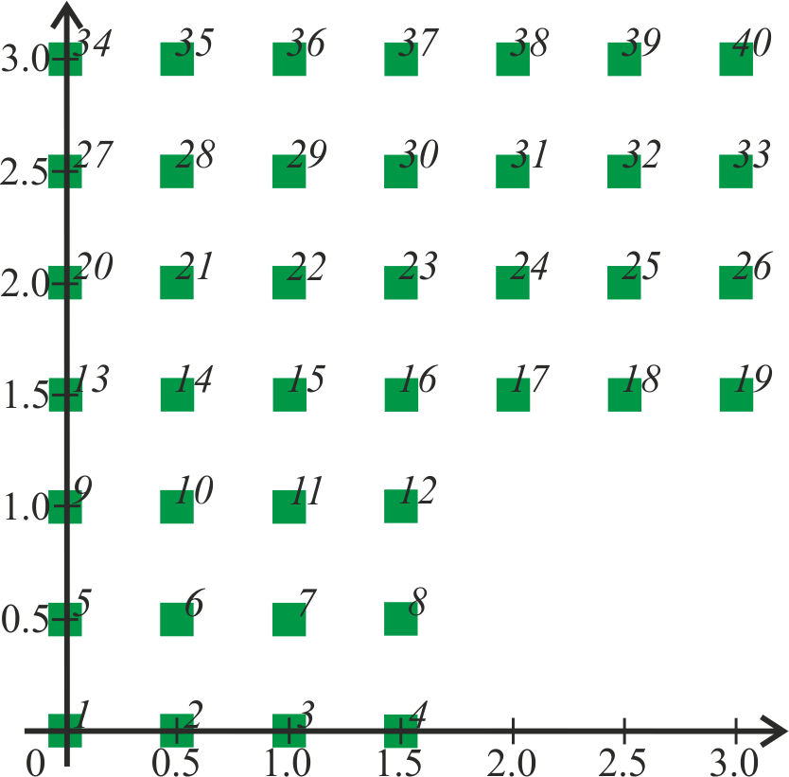***3) Тест на полиноме первой степени***

Искомая функция: 

Уравнение: 

Краевые условия: первого рода на всех ребрах.

|  |  |  |  |  |
| --- | --- | --- | --- | --- |
| **x** | **y** | **u** | **u\*** | **|u*-u|** |
| 0.00 | 0.00 | 0.0000000000000000E+00 | 0.0000000000000000E+00 | 0.000E+00 |
| 0.50 | 0.00 | 5.0000000000000000E-01 | 5.0000000000000000E-01 | 0.000E+00 |
| 1.00 | 0.00 | 1.0000000000000000E+00 | 1.0000000000000000E+00 | 0.000E+00 |
| 1.50 | 0.00 | 1.5000000000000000E+00 | 1.5000000000000000E+00 | 0.000E+00 |
| 0.00 | 0.50 | 5.0000000000000000E-01 | 5.0000000000000000E-01 | 0.000E+00 |
| 0.50 | 0.50 | 9.9999999999999900E-01 | 1.0000000000000000E+00 | 9.992E-16 |
| 1.00 | 0.50 | 1.5000000000000000E+00 | 1.5000000000000000E+00 | 0.000E+00 |
| 1.50 | 0.50 | 2.0000000000000000E+00 | 2.0000000000000000E+00 | 0.000E+00 |
| 0.00 | 1.00 | 1.0000000000000000E+00 | 1.0000000000000000E+00 | 0.000E+00 |
| 0.50 | 1.00 | 1.5000000000000000E+00 | 1.5000000000000000E+00 | 0.000E+00 |
| 1.00 | 1.00 | 2.0000000000000000E+00 | 2.0000000000000000E+00 | 0.000E+00 |
| 1.50 | 1.00 | 2.5000000000000000E+00 | 2.5000000000000000E+00 | 0.000E+00 |
| 0.00 | 1.50 | 1.5000000000000000E+00 | 1.5000000000000000E+00 | 0.000E+00 |
| 0.50 | 1.50 | 2.0000000000000000E+00 | 2.0000000000000000E+00 | 0.000E+00 |
| 1.00 | 1.50 | 2.5000000000000000E+00 | 2.5000000000000000E+00 | 0.000E+00 |
| 1.50 | 1.50 | 3.0000000000000000E+00 | 3.0000000000000000E+00 | 0.000E+00 |
| 2.00 | 1.50 | 3.5000000000000000E+00 | 3.5000000000000000E+00 | 0.000E+00 |
| 2.50 | 1.50 | 4.0000000000000000E+00 | 4.0000000000000000E+00 | 0.000E+00 |
| 3.00 | 1.50 | 4.5000000000000000E+00 | 4.5000000000000000E+00 | 0.000E+00 |
| 0.00 | 2.00 | 2.0000000000000000E+00 | 2.0000000000000000E+00 | 0.000E+00 |
| 0.50 | 2.00 | 2.4999999999999900E+00 | 2.5000000000000000E+00 | 1.021E-14 |
| 1.00 | 2.00 | 3.0000000000000000E+00 | 3.0000000000000000E+00 | 0.000E+00 |
| 1.50 | 2.00 | 3.5000000000000000E+00 | 3.5000000000000000E+00 | 0.000E+00 |
| 2.00 | 2.00 | 4.0000000000000000E+00 | 4.0000000000000000E+00 | 0.000E+00 |
| 2.50 | 2.00 | 4.5000000000000000E+00 | 4.5000000000000000E+00 | 0.000E+00 |
| 3.00 | 2.00 | 5.0000000000000000E+00 | 5.0000000000000000E+00 | 0.000E+00 |
| 0.00 | 2.50 | 2.5000000000000000E+00 | 2.5000000000000000E+00 | 0.000E+00 |
| 0.50 | 2.50 | 3.0000000000000000E+00 | 3.0000000000000000E+00 | 0.000E+00 |
| 1.00 | 2.50 | 3.5000000000000000E+00 | 3.5000000000000000E+00 | 0.000E+00 |
| 1.50 | 2.50 | 4.0000000000000000E+00 | 4.0000000000000000E+00 | 0.000E+00 |
| 2.00 | 2.50 | 4.5000000000000000E+00 | 4.5000000000000000E+00 | 0.000E+00 |
| 2.50 | 2.50 | 5.0000000000000000E+00 | 5.0000000000000000E+00 | 0.000E+00 |
| 3.00 | 2.50 | 5.5000000000000000E+00 | 5.5000000000000000E+00 | 0.000E+00 |
| 0.00 | 3.00 | 3.0000000000000000E+00 | 3.0000000000000000E+00 | 0.000E+00 |
| 0.50 | 3.00 | 3.5000000000000000E+00 | 3.5000000000000000E+00 | 0.000E+00 |
| 1.00 | 3.00 | 4.0000000000000000E+00 | 4.0000000000000000E+00 | 0.000E+00 |
| 1.50 | 3.00 | 4.5000000000000000E+00 | 4.5000000000000000E+00 | 0.000E+00 |
| 2.00 | 3.00 | 5.0000000000000000E+00 | 5.0000000000000000E+00 | 0.000E+00 |
| 2.50 | 3.00 | 5.5000000000000000E+00 | 5.5000000000000000E+00 | 0.000E+00 |
| 3.00 | 3.00 | 6.0000000000000000E+00 | 6.0000000000000000E+00 | 0.000E+00 |

= 4.811E-16

***4) Тест на полиноме второй степени***

Искомая функция: 

Уравнение: 

Краевые условия: первого рода на всех ребрах.

|  |  |  |  |  |
| --- | --- | --- | --- | --- |
| **x** | **y** | **u** | **u\*** | **|u*-u|** |
| 0.00 | 0.00 | 0.0000000000000000E+00 | 0.0000000000000000E+00 | 0.000E+00 |
| 0.50 | 0.00 | 2.5000000000000000E-01 | 2.5000000000000000E-01 | 0.000E+00 |
| 1.00 | 0.00 | 1.0000000000000000E+00 | 1.0000000000000000E+00 | 0.000E+00 |
| 1.50 | 0.00 | 2.2500000000000000E+00 | 2.2500000000000000E+00 | 0.000E+00 |
| 0.00 | 0.50 | 2.5000000000000000E-01 | 2.5000000000000000E-01 | 0.000E+00 |
| 0.50 | 0.50 | 4.9999999999999900E-01 | 5.0000000000000000E-01 | 9.992E-16 |
| 1.00 | 0.50 | 1.2500000000000000E+00 | 1.2500000000000000E+00 | 0.000E+00 |
| 1.50 | 0.50 | 2.5000000000000000E+00 | 2.5000000000000000E+00 | 0.000E+00 |
| 0.00 | 1.00 | 1.0000000000000000E+00 | 1.0000000000000000E+00 | 0.000E+00 |
| 0.50 | 1.00 | 1.2499999999999900E+00 | 1.2500000000000000E+00 | 9.992E-15 |
| 1.00 | 1.00 | 1.9999999999999900E+00 | 2.0000000000000000E+00 | 9.992E-15 |
| 1.50 | 1.00 | 3.2500000000000000E+00 | 3.2500000000000000E+00 | 0.000E+00 |
| 0.00 | 1.50 | 2.2500000000000000E+00 | 2.2500000000000000E+00 | 0.000E+00 |
| 0.50 | 1.50 | 2.4999999999999900E+00 | 2.5000000000000000E+00 | 1.021E-14 |
| 1.00 | 1.50 | 3.2499999999999900E+00 | 3.2500000000000000E+00 | 1.021E-14 |
| 1.50 | 1.50 | 4.5000000000000000E+00 | 4.5000000000000000E+00 | 0.000E+00 |
| 2.00 | 1.50 | 6.2500000000000000E+00 | 6.2500000000000000E+00 | 0.000E+00 |
| 2.50 | 1.50 | 8.5000000000000000E+00 | 8.5000000000000000E+00 | 0.000E+00 |
| 3.00 | 1.50 | 1.1250000000000000E+01 | 1.1250000000000000E+01 | 0.000E+00 |
| 0.00 | 2.00 | 4.0000000000000000E+00 | 4.0000000000000000E+00 | 0.000E+00 |
| **x** | **y** | **u** | **u\*** | **|u*-u|** |
| 0.50 | 2.00 | 4.2499999999999900E+00 | 4.2500000000000000E+00 | 9.770E-15 |
| 1.00 | 2.00 | 5.0000000000000000E+00 | 5.0000000000000000E+00 | 0.000E+00 |
| 1.50 | 2.00 | 6.2500000000000000E+00 | 6.2500000000000000E+00 | 0.000E+00 |
| 2.00 | 2.00 | 8.0000000000000000E+00 | 8.0000000000000000E+00 | 0.000E+00 |
| 2.50 | 2.00 | 1.0250000000000000E+01 | 1.0250000000000000E+01 | 0.000E+00 |
| 3.00 | 2.00 | 1.3000000000000000E+01 | 1.3000000000000000E+01 | 0.000E+00 |
| 0.00 | 2.50 | 6.2500000000000000E+00 | 6.2500000000000000E+00 | 0.000E+00 |
| 0.50 | 2.50 | 6.5000000000000000E+00 | 6.5000000000000000E+00 | 0.000E+00 |
| 1.00 | 2.50 | 7.2500000000000000E+00 | 7.2500000000000000E+00 | 0.000E+00 |
| 1.50 | 2.50 | 8.5000000000000000E+00 | 8.5000000000000000E+00 | 0.000E+00 |
| 2.00 | 2.50 | 1.0250000000000000E+01 | 1.0250000000000000E+01 | 0.000E+00 |
| 2.50 | 2.50 | 1.2500000000000000E+01 | 1.2500000000000000E+01 | 0.000E+00 |
| 3.00 | 2.50 | 1.5250000000000000E+01 | 1.5250000000000000E+01 | 0.000E+00 |
| 0.00 | 3.00 | 9.0000000000000000E+00 | 9.0000000000000000E+00 | 0.000E+00 |
| 0.50 | 3.00 | 9.2500000000000000E+00 | 9.2500000000000000E+00 | 0.000E+00 |
| 1.00 | 3.00 | 1.0000000000000000E+01 | 1.0000000000000000E+01 | 0.000E+00 |
| 1.50 | 3.00 | 1.1250000000000000E+01 | 1.1250000000000000E+01 | 0.000E+00 |
| 2.00 | 3.00 | 1.3000000000000000E+01 | 1.3000000000000000E+01 | 0.000E+00 |
| 2.50 | 3.00 | 1.5250000000000000E+01 | 1.5250000000000000E+01 | 0.000E+00 |
| 3.00 | 3.00 | 1.8000000000000000E+01 | 1.8000000000000000E+01 | 0.000E+00 |

= 4.435E-16

***5) Тест на полиноме третьей степени***

Искомая функция: 

Уравнение: 

Краевые условия: первого рода на всех ребрах.

|  |  |  |  |  |
| --- | --- | --- | --- | --- |
| **x** | **y** | **u** | **u\*** | **|u*-u|** |
| 0.00 | 0.00 | 0.0000000000000000E+00 | 0.0000000000000000E+00 | 0.000E+00 |
| 0.50 | 0.00 | 1.2500000000000000E-01 | 1.2500000000000000E-01 | 0.000E+00 |
| 1.00 | 0.00 | 1.0000000000000000E+00 | 1.0000000000000000E+00 | 0.000E+00 |
| 1.50 | 0.00 | 3.3750000000000000E+00 | 3.3750000000000000E+00 | 0.000E+00 |
| 0.00 | 0.50 | 1.2500000000000000E-01 | 1.2500000000000000E-01 | 0.000E+00 |
| 0.50 | 0.50 | 2.4999999999999900E-01 | 2.5000000000000000E-01 | 9.992E-16 |
| 1.00 | 0.50 | 1.1250000000000000E+00 | 1.1250000000000000E+00 | 0.000E+00 |
| 1.50 | 0.50 | 3.5000000000000000E+00 | 3.5000000000000000E+00 | 0.000E+00 |
| 0.00 | 1.00 | 1.0000000000000000E+00 | 1.0000000000000000E+00 | 0.000E+00 |
| 0.50 | 1.00 | 1.1249999999999900E+00 | 1.1250000000000000E+00 | 9.992E-15 |
| 1.00 | 1.00 | 1.9999999999999900E+00 | 2.0000000000000000E+00 | 9.992E-15 |
| 1.50 | 1.00 | 4.3750000000000000E+00 | 4.3750000000000000E+00 | 0.000E+00 |
| 0.00 | 1.50 | 3.3750000000000000E+00 | 3.3750000000000000E+00 | 0.000E+00 |
| 0.50 | 1.50 | 3.5000000000000000E+00 | 3.5000000000000000E+00 | 0.000E+00 |
| 1.00 | 1.50 | 4.3750000000000000E+00 | 4.3750000000000000E+00 | 0.000E+00 |
| 1.50 | 1.50 | 6.7500000000000000E+00 | 6.7500000000000000E+00 | 0.000E+00 |
| 2.00 | 1.50 | 1.1375000000000000E+01 | 1.1375000000000000E+01 | 0.000E+00 |
| 2.50 | 1.50 | 1.9000000000000000E+01 | 1.9000000000000000E+01 | 0.000E+00 |
| 3.00 | 1.50 | 3.0375000000000000E+01 | 3.0375000000000000E+01 | 0.000E+00 |
| 0.00 | 2.00 | 8.0000000000000000E+00 | 8.0000000000000000E+00 | 0.000E+00 |
| 0.50 | 2.00 | 8.1250000000000000E+00 | 8.1250000000000000E+00 | 0.000E+00 |
| 1.00 | 2.00 | 9.0000000000000000E+00 | 9.0000000000000000E+00 | 0.000E+00 |
| 1.50 | 2.00 | 1.1375000000000000E+01 | 1.1375000000000000E+01 | 0.000E+00 |
| 2.00 | 2.00 | 1.6000000000000000E+01 | 1.6000000000000000E+01 | 0.000E+00 |
| 2.50 | 2.00 | 2.3625000000000000E+01 | 2.3625000000000000E+01 | 0.000E+00 |
| 3.00 | 2.00 | 3.5000000000000000E+01 | 3.5000000000000000E+01 | 0.000E+00 |
| 0.00 | 2.50 | 1.5625000000000000E+01 | 1.5625000000000000E+01 | 0.000E+00 |
| 0.50 | 2.50 | 1.5750000000000000E+01 | 1.5750000000000000E+01 | 0.000E+00 |
| 1.00 | 2.50 | 1.6625000000000000E+01 | 1.6625000000000000E+01 | 0.000E+00 |
| 1.50 | 2.50 | 1.9000000000000000E+01 | 1.9000000000000000E+01 | 0.000E+00 |
| 2.00 | 2.50 | 2.3625000000000000E+01 | 2.3625000000000000E+01 | 0.000E+00 |
| 2.50 | 2.50 | 3.1250000000000000E+01 | 3.1250000000000000E+01 | 0.000E+00 |
| 3.00 | 2.50 | 4.2625000000000000E+01 | 4.2625000000000000E+01 | 0.000E+00 |
| 0.00 | 3.00 | 2.7000000000000000E+01 | 2.7000000000000000E+01 | 0.000E+00 |
| 0.50 | 3.00 | 2.7125000000000000E+01 | 2.7125000000000000E+01 | 0.000E+00 |
| 1.00 | 3.00 | 2.8000000000000000E+01 | 2.8000000000000000E+01 | 0.000E+00 |
| 1.50 | 3.00 | 3.0375000000000000E+01 | 3.0375000000000000E+01 | 0.000E+00 |
| 2.00 | 3.00 | 3.5000000000000000E+01 | 3.5000000000000000E+01 | 0.000E+00 |
| 2.50 | 3.00 | 4.2625000000000000E+01 | 4.2625000000000000E+01 | 0.000E+00 |
| 3.00 | 3.00 | 5.4000000000000000E+01 | 5.4000000000000000E+01 | 0.000E+00 |

= 1.070E-16

***6) Тест на полиноме четвертой степени***

Искомая функция: 

Уравнение: 

Краевые условия: первого рода на всех ребрах.

|  |  |  |  |  |
| --- | --- | --- | --- | --- |
| **x** | **y** | **u** | **u\*** | **|u*-u|** |
| 0.00 | 0.00 | 0.0000000000000000E+00 | 0.0000000000000000E+00 | 0.000E+00 |
| 0.50 | 0.00 | 6.2500000000000000E-02 | 6.2500000000000000E-02 | 0.000E+00 |
| 1.00 | 0.00 | 1.0000000000000000E+00 | 1.0000000000000000E+00 | 0.000E+00 |
| 1.50 | 0.00 | 5.0625000000000000E+00 | 5.0625000000000000E+00 | 0.000E+00 |
| 0.00 | 0.50 | 6.2500000000000000E-02 | 6.2500000000000000E-02 | 0.000E+00 |
| 0.50 | 0.50 | 2.4186637258088100E-01 | 1.2500000000000000E-01 | 1.169E-01 |
| 1.00 | 0.50 | 1.1806916016976200E+00 | 1.0625000000000000E+00 | 1.182E-01 |
| 1.50 | 0.50 | 5.1250000000000000E+00 | 5.1250000000000000E+00 | 0.000E+00 |
| 0.00 | 1.00 | 1.0000000000000000E+00 | 1.0000000000000000E+00 | 0.000E+00 |
| 0.50 | 1.00 | 1.2202070749163500E+00 | 1.0625000000000000E+00 | 1.577E-01 |
| 1.00 | 1.00 | 2.1649958350584200E+00 | 2.0000000000000000E+00 | 1.650E-01 |
| 1.50 | 1.00 | 6.0625000000000000E+00 | 6.0625000000000000E+00 | 0.000E+00 |
| 0.00 | 1.50 | 5.0625000000000000E+00 | 5.0625000000000000E+00 | 0.000E+00 |
| 0.50 | 1.50 | 5.3028196294842700E+00 | 5.1250000000000000E+00 | 1.778E-01 |
| 1.00 | 1.50 | 6.2790825811489200E+00 | 6.0625000000000000E+00 | 2.166E-01 |
| 1.50 | 1.50 | 1.0276814480510600E+01 | 1.0125000000000000E+01 | 1.518E-01 |
| 2.00 | 1.50 | 2.1062500000000000E+01 | 2.1062500000000000E+01 | 0.000E+00 |
| 2.50 | 1.50 | 4.4125000000000000E+01 | 4.4125000000000000E+01 | 0.000E+00 |
| 3.00 | 1.50 | 8.6062500000000000E+01 | 8.6062500000000000E+01 | 0.000E+00 |
| 0.00 | 2.00 | 1.6000000000000000E+01 | 1.6000000000000000E+01 | 0.000E+00 |
| 0.50 | 2.00 | 1.6238398676613900E+01 | 1.6062500000000000E+01 | 1.759E-01 |
| 1.00 | 2.00 | 1.7229991670116800E+01 | 1.7000000000000000E+01 | 2.300E-01 |
| 1.50 | 2.00 | 2.1279082581148900E+01 | 2.1062500000000000E+01 | 2.166E-01 |
| 2.00 | 2.00 | 3.2164995835058400E+01 | 3.2000000000000000E+01 | 1.650E-01 |
| 2.50 | 2.00 | 5.5180691601697600E+01 | 5.5062500000000000E+01 | 1.182E-01 |
| 3.00 | 2.00 | 9.7000000000000000E+01 | 9.7000000000000000E+01 | 0.000E+00 |
| 0.00 | 2.50 | 3.9062500000000000E+01 | 3.9062500000000000E+01 | 0.000E+00 |
| 0.50 | 2.50 | 3.9258732745161700E+01 | 3.9125000000000000E+01 | 1.337E-01 |
| 1.00 | 2.50 | 4.0238398676613900E+01 | 4.0062500000000000E+01 | 1.759E-01 |
| 1.50 | 2.50 | 4.4302819629484200E+01 | 4.4125000000000000E+01 | 1.778E-01 |
| 2.00 | 2.50 | 5.5220207074916300E+01 | 5.5062500000000000E+01 | 1.577E-01 |
| 2.50 | 2.50 | 7.8241866372580800E+01 | 7.8125000000000000E+01 | 1.169E-01 |
| 3.00 | 2.50 | 1.2006250000000000E+02 | 1.2006250000000000E+02 | 0.000E+00 |
| 0.00 | 3.00 | 8.1000000000000000E+01 | 8.1000000000000000E+01 | 0.000E+00 |
| 0.50 | 3.00 | 8.1062500000000000E+01 | 8.1062500000000000E+01 | 0.000E+00 |
| 1.00 | 3.00 | 8.2000000000000000E+01 | 8.2000000000000000E+01 | 0.000E+00 |
| 1.50 | 3.00 | 8.6062500000000000E+01 | 8.6062500000000000E+01 | 0.000E+00 |
| 2.00 | 3.00 | 9.7000000000000000E+01 | 9.7000000000000000E+01 | 0.000E+00 |
| 2.50 | 3.00 | 1.2006250000000000E+02 | 1.2006250000000000E+02 | 0.000E+00 |
| 3.00 | 3.00 | 1.6200000000000000E+02 | 1.6200000000000000E+02 | 0.000E+00 |

= 1.889E-03

***7) Тесты на определение порядка аппроксимации на неполиномиальных решениях***

Искомая функция: 

Уравнение: 

Краевые условия: первого рода на всех ребрах.

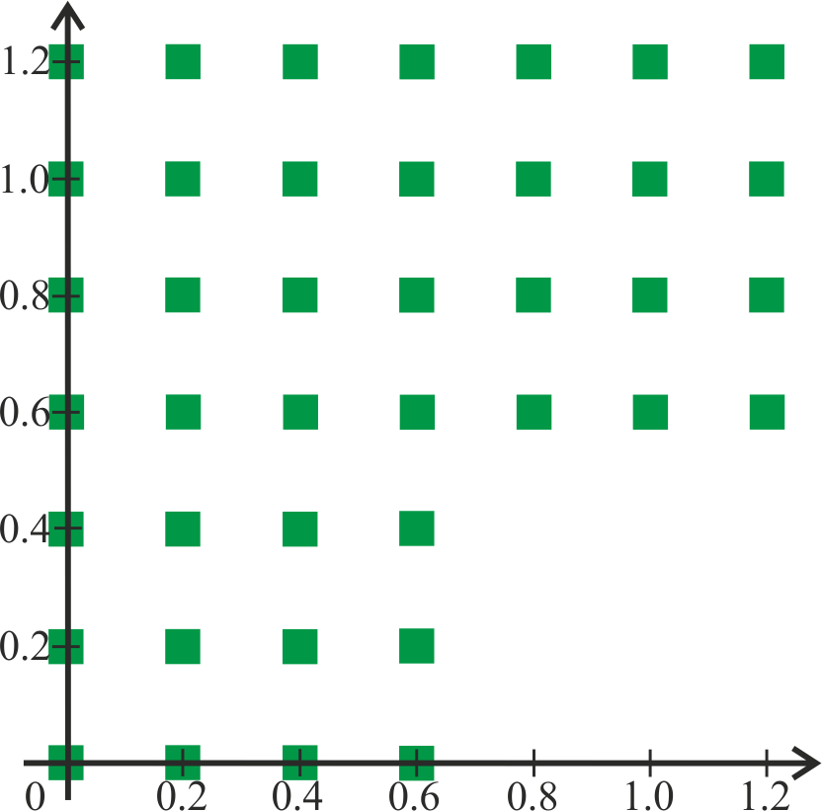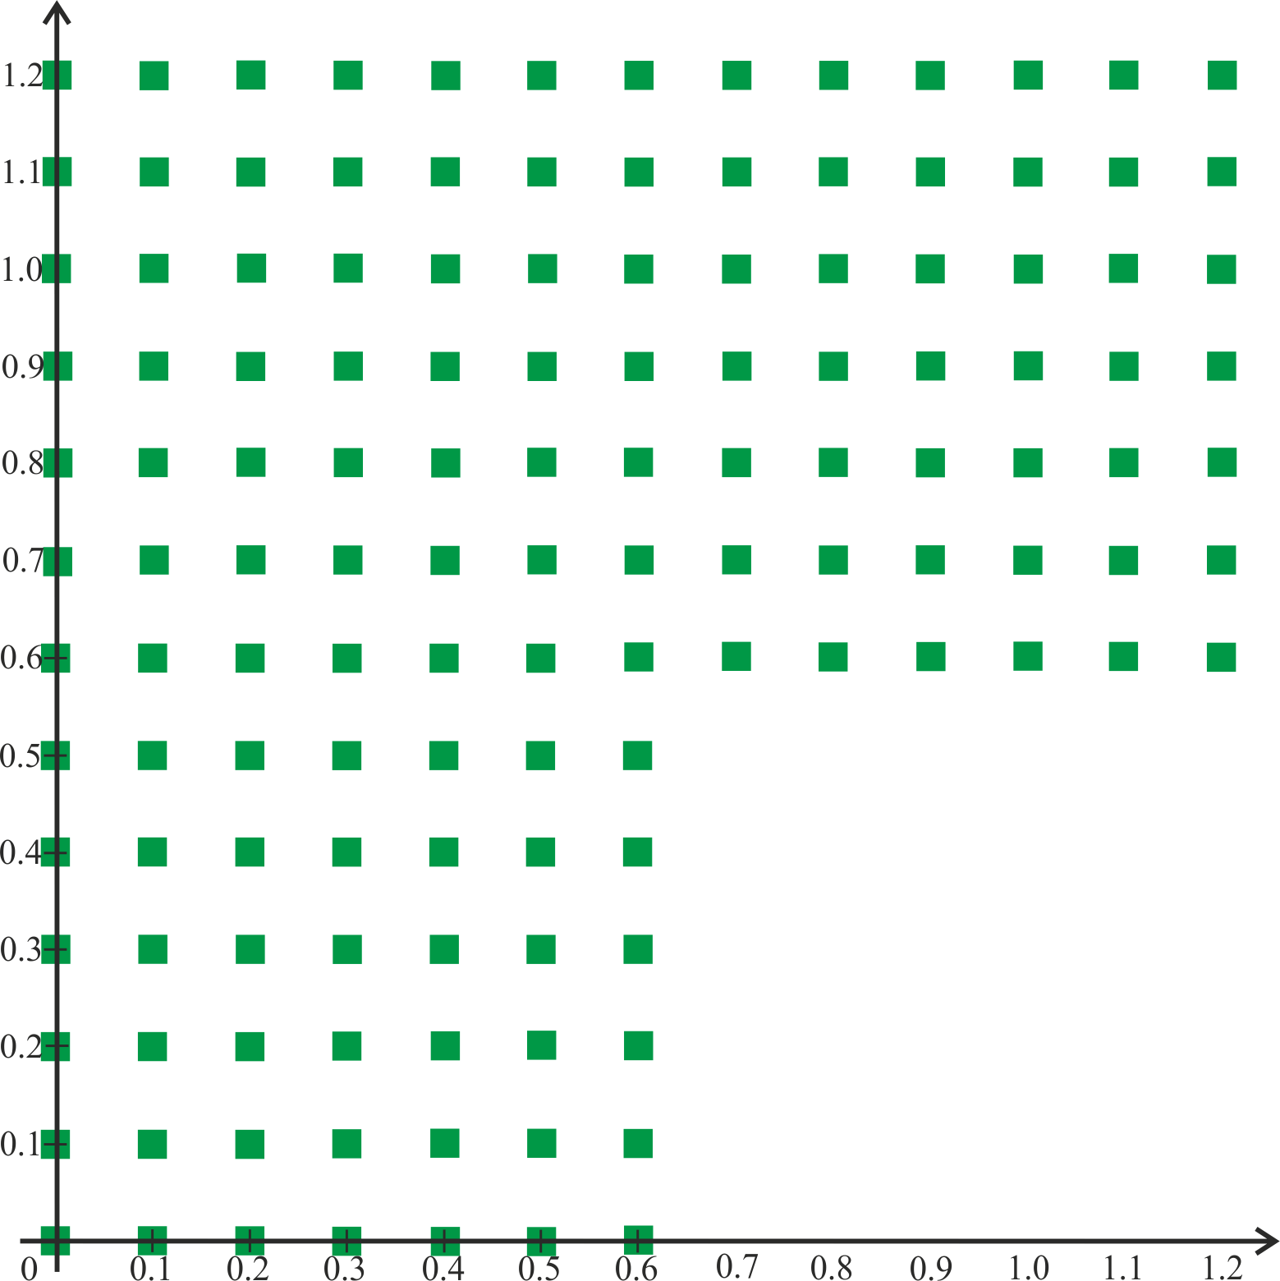

|  |  |  |  |  |  |  |  |  |
| --- | --- | --- | --- | --- | --- | --- | --- | --- |
| **x** | **y** | **uh** | **uh/2** | **uh/4** | **u\*** | **|u*-uh|** | **|u*-uh/2|** | **|u*-uh/4|** |
| 0.00 | 0.00 | 1.0000000000000000E+00 | 1.0000000000000000E+00 | 1.0000000000000000E+00 | 1.0000000000000000E+00 | 0.000E+00 | 0.000E+00 | 0.000E+00 |
| 0.20 | 0.00 | 9.2106099400288500E-01 | 9.2106099400288500E-01 | 9.2106099400288500E-01 | 9.2106099400288500E-01 | 1.110E-16 | 1.110E-16 | 1.110E-16 |
| 0.40 | 0.00 | 6.9670670934716500E-01 | 6.9670670934716500E-01 | 6.9670670934716500E-01 | 6.9670670934716500E-01 | 3.331E-16 | 3.331E-16 | 3.331E-16 |
| 0.60 | 0.00 | 3.6235800000000000E-01 | 3.6235800000000000E-01 | 3.6235800000000000E-01 | 3.6235775447667600E-01 | 2.455E-07 | 2.455E-07 | 2.455E-07 |
| 0.00 | 0.20 | 9.2106099400288500E-01 | 9.2106099400288500E-01 | 9.2106099400288500E-01 | 9.2106099400288500E-01 | 1.110E-16 | 1.110E-16 | 1.110E-16 |
| 0.20 | 0.20 | 6.9761750305646700E-01 | 6.9695727980980000E-01 | 6.9677117296062900E-01 | 6.9670670934716500E-01 | 9.108E-04 | 2.506E-04 | 6.446E-05 |
| 0.40 | 0.20 | 3.6285560066593800E-01 | 3.6250476108588600E-01 | 3.6239630380956600E-01 | 3.6235775447667300E-01 | 4.978E-04 | 1.470E-04 | 3.855E-05 |
| 0.60 | 0.20 | -2.9199522301288800E-02 | -2.9199522301288800E-02 | -2.9199522301288800E-02 | -2.9199522301286600E-02 | 2.207E-15 | 2.207E-15 | 2.207E-15 |
| 0.00 | 0.40 | 6.9670670934716500E-01 | 6.9670670934716500E-01 | 6.9670670934716500E-01 | 6.9670670934716500E-01 | 3.331E-16 | 3.331E-16 | 3.331E-16 |
| 0.20 | 0.40 | 3.6258270831143900E-01 | 3.6243877432241200E-01 | 3.6238016856236300E-01 | 3.6235775447667300E-01 | 2.250E-04 | 8.102E-05 | 2.241E-05 |
| 0.40 | 0.40 | -2.9636855023553700E-02 | -2.9272481983156700E-02 | -2.9214357803016400E-02 | -2.9199522301288800E-02 | 4.373E-04 | 7.296E-05 | 1.484E-05 |
| 0.60 | 0.40 | -4.1614683654714200E-01 | -4.1614683654714200E-01 | -4.1614683654714200E-01 | -4.1614683654714100E-01 | 1.443E-15 | 1.443E-15 | 1.443E-15 |
| 0.00 | 0.60 | 3.6235775447667300E-01 | 3.6235775447667300E-01 | 3.6235775447667300E-01 | 3.6235775447667600E-01 | 2.498E-15 | 2.498E-15 | 2.498E-15 |
| 0.20 | 0.60 | -3.0302007413467800E-02 | -2.9442231768831600E-02 | -2.9257460982625500E-02 | -2.9199522301286600E-02 | 1.102E-03 | 2.427E-04 | 5.794E-05 |
| 0.40 | 0.60 | -4.1851253869692800E-01 | -4.1664874201211000E-01 | -4.1626451554671800E-01 | -4.1614683654714100E-01 | 2.366E-03 | 5.019E-04 | 1.177E-04 |
| 0.60 | 0.60 | -7.3982744122412700E-01 | -7.3775560767362500E-01 | -7.3744931005469600E-01 | -7.3739371554124300E-01 | 2.434E-03 | 3.619E-04 | 5.559E-05 |
| 0.80 | 0.60 | -9.4222234066865800E-01 | -9.4222234066865800E-01 | -9.4222234066865800E-01 | -9.4222234066865800E-01 | 4.441E-16 | 4.441E-16 | 4.441E-16 |
| 1.00 | 0.60 | -9.9829477579475300E-01 | -9.9829477579475300E-01 | -9.9829477579475300E-01 | -9.9829477579475300E-01 | 2.220E-16 | 2.220E-16 | 2.220E-16 |
| 1.20 | 0.60 | -8.9675800000000000E-01 | -8.9675800000000000E-01 | -8.9675800000000000E-01 | -8.9675841633414800E-01 | 4.163E-07 | 4.163E-07 | 4.163E-07 |
| 0.00 | 0.80 | -2.9199522301288800E-02 | -2.9199522301288800E-02 | -2.9199522301288800E-02 | -2.9199522301288800E-02 | 1.388E-17 | 1.388E-17 | 1.388E-17 |
| 0.20 | 0.80 | -4.1833620601313000E-01 | -4.1667044628117000E-01 | -4.1627544764165900E-01 | -4.1614683654714200E-01 | 2.189E-03 | 5.236E-04 | 1.286E-04 |
| 0.40 | 0.80 | -7.4121149151746900E-01 | -7.3828546450367600E-01 | -7.3761056608988300E-01 | -7.3739371554124600E-01 | 3.818E-03 | 8.917E-04 | 2.169E-04 |
| 0.60 | 0.80 | -9.4655940903789700E-01 | -9.4320614239814500E-01 | -9.4245989140209300E-01 | -9.4222234066865800E-01 | 4.337E-03 | 9.838E-04 | 2.376E-04 |
| 0.80 | 0.80 | -1.0017966180609700E+00 | -9.9914840405642800E-01 | -9.9850584149698900E-01 | -9.9829477579475300E-01 | 3.502E-03 | 8.536E-04 | 2.111E-04 |
| 1.00 | 0.80 | -8.9907869397754600E-01 | -8.9734154487353200E-01 | -8.9690425948443300E-01 | -8.9675841633414700E-01 | 2.320E-03 | 5.831E-04 | 1.458E-04 |
| 1.20 | 0.80 | -6.5364362086361100E-01 | -6.5364362086361100E-01 | -6.5364362086361100E-01 | -6.5364362086361200E-01 | 8.882E-16 | 8.882E-16 | 8.882E-16 |
| 0.00 | 1.00 | -4.1614683654714200E-01 | -4.1614683654714200E-01 | -4.1614683654714200E-01 | -4.1614683654714200E-01 | 3.886E-16 | 3.886E-16 | 3.886E-16 |
| 0.20 | 1.00 | -7.3955238990384900E-01 | -7.3792853594724800E-01 | -7.3752675952916700E-01 | -7.3739371554124500E-01 | 2.159E-03 | 5.348E-04 | 1.330E-04 |
| 0.40 | 1.00 | -9.4562453438777300E-01 | -9.4304932585640300E-01 | -9.4242679829891000E-01 | -9.4222234066865800E-01 | 3.402E-03 | 8.270E-04 | 2.045E-04 |
| 0.60 | 1.00 | -1.0020644190698100E+00 | -9.9920516437436600E-01 | -9.9851981688980500E-01 | -9.9829477579475300E-01 | 3.770E-03 | 9.104E-04 | 2.250E-04 |
| 0.80 | 1.00 | -9.0001177399612600E-01 | -8.9756205731549400E-01 | -8.9695822461673900E-01 | -8.9675841633414700E-01 | 3.253E-03 | 8.036E-04 | 1.998E-04 |
| 1.00 | 1.00 | -6.5570987906965600E-01 | -6.5416094319321600E-01 | -6.5377281568897500E-01 | -6.5364362086361200E-01 | 2.066E-03 | 5.173E-04 | 1.292E-04 |
| 1.20 | 1.00 | -3.0733286997841900E-01 | -3.0733286997841900E-01 | -3.0733286997841900E-01 | -3.0733286997841900E-01 | 3.331E-16 | 3.331E-16 | 3.331E-16 |
| 0.00 | 1.20 | -7.3739399999999900E-01 | -7.3739399999999900E-01 | -7.3739399999999900E-01 | -7.3739371554124500E-01 | 2.845E-07 | 2.845E-07 | 2.845E-07 |
| 0.20 | 1.20 | -9.4222234066865800E-01 | -9.4222234066865800E-01 | -9.4222234066865800E-01 | -9.4222234066865800E-01 | 1.110E-16 | 1.110E-16 | 1.110E-16 |
| 0.40 | 1.20 | -9.9829477579475300E-01 | -9.9829477579475300E-01 | -9.9829477579475300E-01 | -9.9829477579475300E-01 | 1.110E-16 | 1.110E-16 | 1.110E-16 |
| 0.60 | 1.20 | -8.9675841633414700E-01 | -8.9675841633414700E-01 | -8.9675841633414700E-01 | -8.9675841633414800E-01 | 9.992E-16 | 9.992E-16 | 9.992E-16 |
| 0.80 | 1.20 | -6.5364362086361100E-01 | -6.5364362086361100E-01 | -6.5364362086361100E-01 | -6.5364362086361200E-01 | 8.882E-16 | 8.882E-16 | 8.882E-16 |
| 1.00 | 1.20 | -3.0733286997841900E-01 | -3.0733286997841900E-01 | -3.0733286997841900E-01 | -3.0733286997841900E-01 | 3.331E-16 | 3.331E-16 | 3.331E-16 |
| 1.20 | 1.20 | 8.7498999999999900E-02 | 8.7498999999999900E-02 | 8.7498999999999900E-02 | 8.7498983439446400E-02 | 1.656E-08 | 1.656E-08 | 1.656E-08 |

= 2.413E-03 , = 5.668E-04 , = 1.385E-04

 2.09 , 2.03

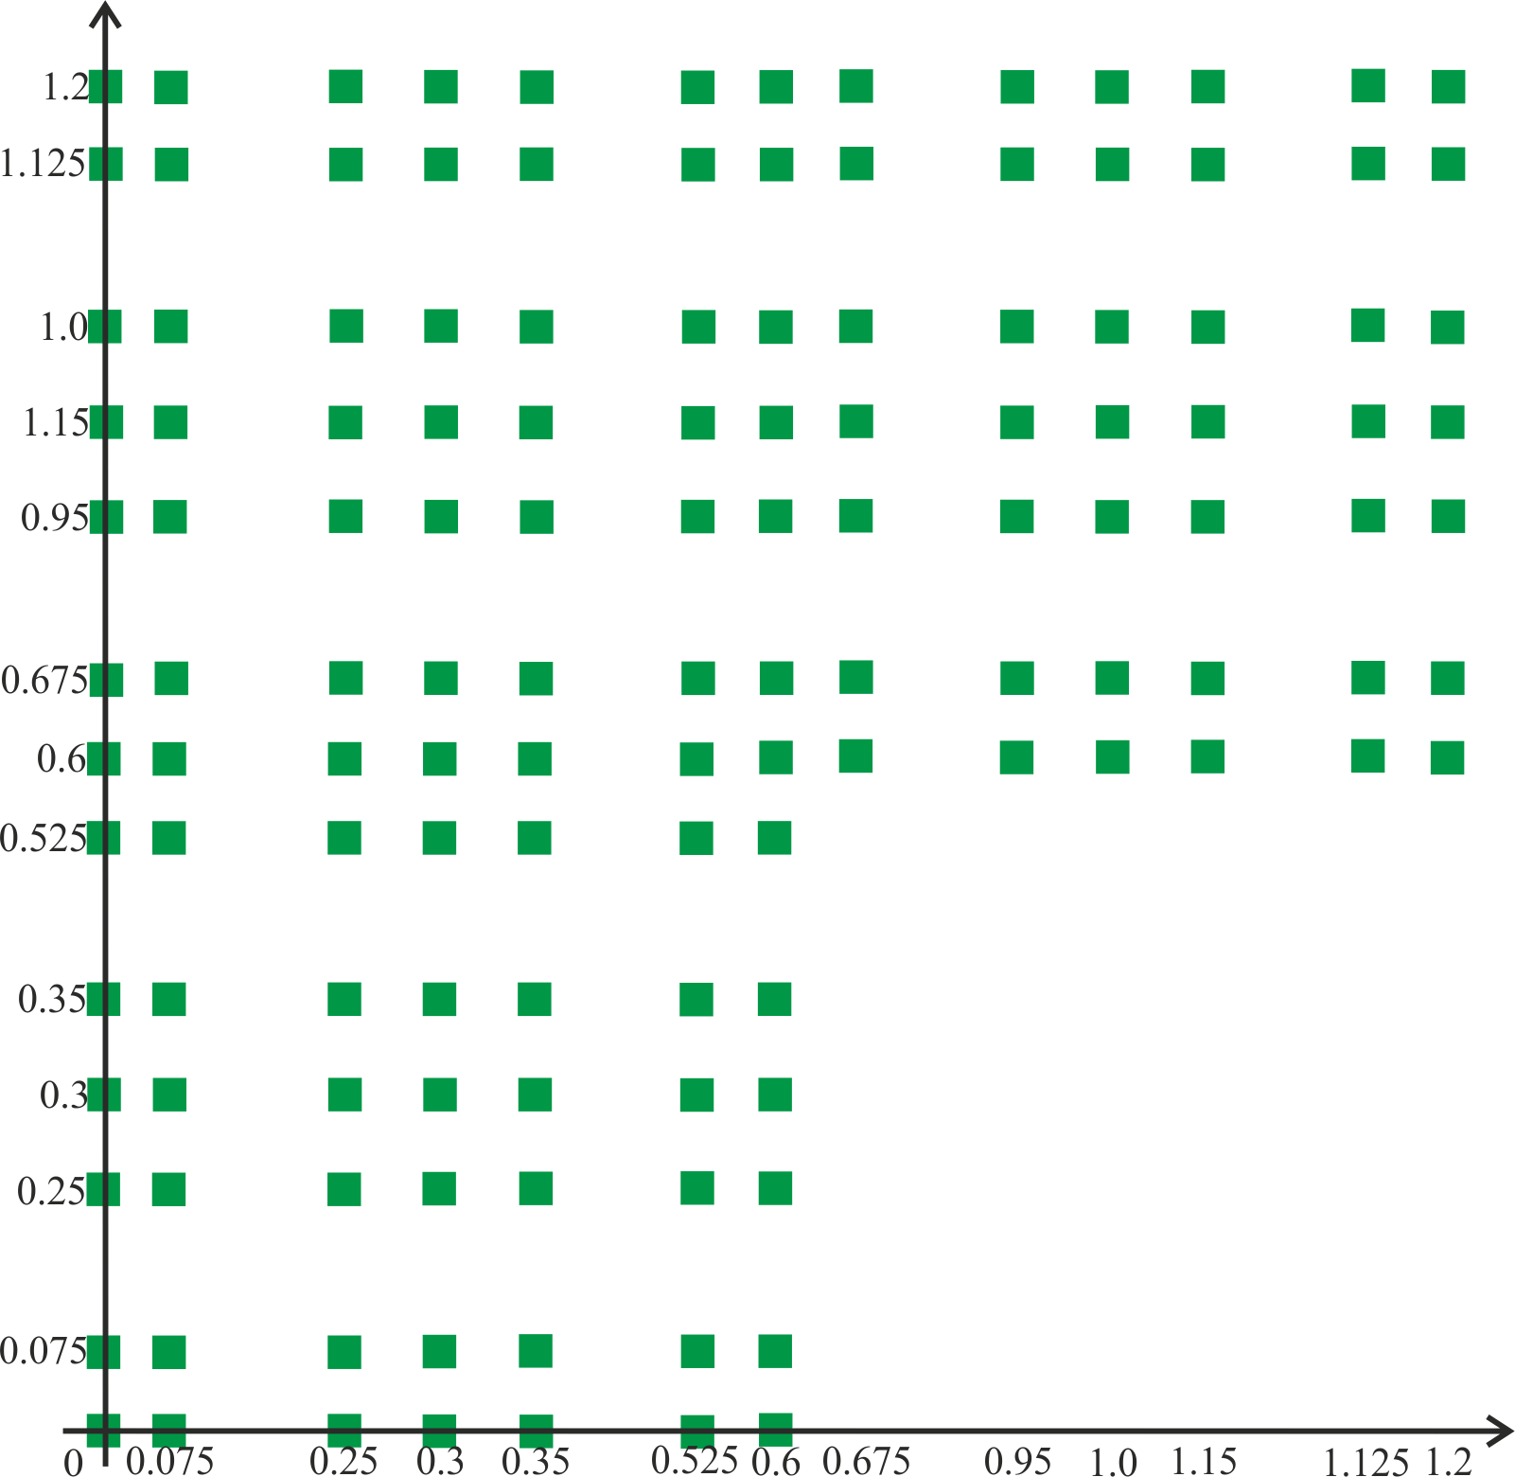***8) Тест на неравномерной сетке***

Искомая функция: 

Уравнение: 

Краевые условия: первого рода на всех ребрах.

= 3.462E-02

**6. Вывод**

Исследованный метод хорошо справляется с решением уравнений с полиномиальными решениями степени до 3 вклю-чительно. При полиномах более высокого порядка, а также при неполиномиальных решениях результаты получаются несколько хуже. Однако, при достаточной малости шага, метод пригоден и для них.

Исследования на порядок аппроксимации подтвердили теоретические предположения – на равномерных сетках с краевыми условиями первого рода метод имеет второй порядок аппроксимации. Использование неравномерных сеток или краевых условий второго рода может привести к понижению порядка вплоть до первого.

**7. Код программы**

module module_fdm

implicit none

type :: area_g

double precision,allocatable :: mesh_x(:),mesh_y(:)

integer :: num_x,num_y,num_g_x,num_g_y,num_all

double precision :: lambda_,gamma_,bound_corner(5)

contains

procedure :: input_g

end type

type :: slae

double precision,allocatable :: di(:),du1(:),du2(:),dl1(:),dl2(:),df(:),x(:)

integer :: shift1,shift2,dshift,n,maxiter=10000

double precision :: eps=1d-15,def_x=1d0,omega=1.0d0

contains

procedure :: calc_gauss_seidel

procedure,private :: norm

end type

type :: fdm

type(area_g) :: area_g

type(slae) :: slae

contains

procedure :: f

procedure :: gettypeofb

procedure :: getvalueofb

procedure :: getslae

procedure :: dealloc

procedure :: write_

end type

contains

function f(this,x,y)

implicit none

type(fdm) :: this

double precision :: f,x,y

!# Test 1,2,3

!f=2d0*x+2d0*y

!# Test 4

!f=2d0*x**2+2d0*y**2-4d0

!# Test 5

!f=2d0*x**3+2d0*y**3-6d0*x-6d0*y

!# Test 6

!f=2d0*x**4+2d0*y**4-12d0*x**2-12d0*y**2

!# Test 7

f=9d0*cos(2d0*x+2d0*y)

end function

! ----------

! | 6 |

! | | 5

! | 2 ----

! | | 4

! | 1 | 3

! -------

function gettypeofb(this,numb)

implicit none

type(fdm) :: this

integer :: numb,gettypeofb

!# Test 1,3,4,5,6,7

if(numb.eq.1.or.numb.eq.2.or.numb.eq.3.or.numb.eq.4.or.numb.eq.5.or.numb.eq.6) then

gettypeofb=1

end if

!# Test 2

!if(numb.eq.1.or.numb.eq.3.or.numb.eq.5.or.numb.eq.6) then

! gettypeofb=1

!else

! gettypeofb=2

!end if

end function

function getvalueofb(this,numb,x,y)

implicit none

type(fdm) :: this

integer :: numb

double precision :: getvalueofb,x,y

!# Test 1,3

!getvalueofb=x+y

!# Test 2

!if(numb.eq.1.or.numb.eq.3.or.numb.eq.5.or.numb.eq.6) then

! getvalueofb=x+y

!else if(numb.eq.2) then

! getvalueofb=1d0

!else

! getvalueofb=1d0

!end if

!# Test 4

!if(numb.eq.1.or.numb.eq.3.or.numb.eq.5.or.numb.eq.6) then

! getvalueofb=x**2+y**2

!else if(numb.eq.2) then

! getvalueofb=2d0*x

!else

! getvalueofb=2d0*y

!end if

!# Test 4

!getvalueofb=x**2+y**2

!# Test 5

!getvalueofb=x**3+y**3

!# Test 6

!getvalueofb=x**4+y**4

!# Test 7

getvalueofb=cos(2d0*x+2d0*y)

end function

subroutine input_g(this)

implicit none

type(area_g) :: this

integer :: i

open(10,file='../area.txt',status='old')

read(10,*) this%num_x,this%num_y

allocate(this%mesh_x(this%num_x))

allocate(this%mesh_y(this%num_y))

read(10,*) (this%mesh_x(i), i=1,this%num_x)

read(10,*) (this%mesh_y(i), i=1,this%num_y)

read(10,*) this%num_g_x,this%num_g_y

read(10,*) this%lambda_,this%gamma_

close(10)

this%num_all=this%num_g_x*(this%num_g_y-1)+(this%num_y-this%num_g_y+1)*this%num_x

open(20,file='../bcorner.txt',status='old')

read(20,*) (this%bound_corner(i), i=1,5)

close(20)

end subroutine

subroutine getslae(this)

implicit none

type(fdm) :: this

integer :: i,j,t

double precision :: hx1,hx2,hy1,hy2

this%slae%n=this%area_g%num_all

allocate(this%slae%di(this%slae%n))

allocate(this%slae%du1(this%slae%n))

allocate(this%slae%du2(this%slae%n))

allocate(this%slae%dl1(this%slae%n))

allocate(this%slae%dl2(this%slae%n))

allocate(this%slae%df(this%slae%n))

this%slae%di=0d0

this%slae%du1=0d0

this%slae%du2=0d0

this%slae%dl1=0d0

this%slae%dl2=0d0

this%slae%df=0d0

this%slae%shift1=this%area_g%num_g_x

this%slae%shift2=this%area_g%num_x

! нижняя плоскость "Г"

this%slae%di(1)=1d0

this%slae%df(1)=this%area_g%bound_corner(1)

hy1=dabs(this%area_g%mesh_y(1)-this%area_g%mesh_y(2))

do i=2,this%area_g%num_g_x-1

this%slae%df(i)=this%getvalueofb(1,this%area_g%mesh_x(i),this%area_g%mesh_y(1))

if(this%gettypeofb(1).eq.2) then

this%slae%di(i)=-this%area_g%lambda_/hy1

this%slae%du2(i)=this%area_g%lambda_/hy1

else

this%slae%di(i)=1d0

end if

end do

t=this%area_g%num_g_x

this%slae%di(t)=1d0

this%slae%df(t)=this%area_g%bound_corner(2)

t=t+1

! ножка "Г"

do i=2,this%area_g%num_g_y-1

hy1=dabs(this%area_g%mesh_y(i)-this%area_g%mesh_y(i-1))

hy2=dabs(this%area_g%mesh_y(i+1)-this%area_g%mesh_y(i))

this%slae%df(t)=this%getvalueofb(2,this%area_g%mesh_x(1),this%area_g%mesh_y(i))

if(this%gettypeofb(2).eq.2) then

hx1=dabs(this%area_g%mesh_x(1)-this%area_g%mesh_x(2))

this%slae%di(t)=-this%area_g%lambda_/hx1

this%slae%du1(t)=this%area_g%lambda_/hx1

else

this%slae%di(t)=1d0

end if

t=t+1

do j=2,this%area_g%num_g_x-1

hx1=dabs(this%area_g%mesh_x(j)-this%area_g%mesh_x(j-1))

hx2=dabs(this%area_g%mesh_x(j+1)-this%area_g%mesh_x(j))

this%slae%df(t)=this%f(this%area_g%mesh_x(j),this%area_g%mesh_y(i))

this%slae%dl1(t-1)=-2d0*this%area_g%lambda_/(hx1*(hx2+hx1))

this%slae%dl2(t-this%slae%shift1)=-2d0*this%area_g%lambda_/(hy1*(hy2+hy1))

this%slae%du1(t)=-2d0*this%area_g%lambda_/(hx2*(hx2+hx1))

this%slae%du2(t)=-2d0*this%area_g%lambda_/(hy2*(hy2+hy1))

this%slae%di(t)=(2d0/(hx1*hx2)+2d0/(hy1*hy2))*this%area_g%lambda_+this%area_g%gamma_

t=t+1

end do

this%slae%df(t)=this%getvalueofb(3,this%area_g%mesh_x(this%area_g%num_g_x),this%area_g%mesh_y(i))

if(this%gettypeofb(3).eq.2) then

hx1=dabs(this%area_g%mesh_x(this%area_g%num_g_x)-this%area_g%mesh_x(this%area_g%num_g_x-1))

this%slae%di(t)=this%area_g%lambda_/hx1

this%slae%dl1(t-1)=-this%area_g%lambda_/hx1

else

this%slae%di(t)=1d0

end if

t=t+1

end do

this%slae%dshift=t

! Между ножкой и шляпкой

hy1=dabs(this%area_g%mesh_y(this%area_g%num_g_y)-this%area_g%mesh_y(this%area_g%num_g_y-1))

hy2=dabs(this%area_g%mesh_y(this%area_g%num_g_y+1)-this%area_g%mesh_y(this%area_g%num_g_y))

this%slae%df(t)=this%getvalueofb(2,this%area_g%mesh_x(1),this%area_g%mesh_y(this%area_g%num_g_y))

if(this%gettypeofb(2).eq.2) then

hx1=dabs(this%area_g%mesh_x(1)-this%area_g%mesh_x(2))

this%slae%di(t)=-this%area_g%lambda_/hx1

this%slae%du1(t)=this%area_g%lambda_/hx1

else

this%slae%di(t)=1d0

end if

t=t+1

do j=2,this%area_g%num_g_x

hx1=dabs(this%area_g%mesh_x(j)-this%area_g%mesh_x(j-1))

hx2=dabs(this%area_g%mesh_x(j+1)-this%area_g%mesh_x(j))

this%slae%df(t)=this%f(this%area_g%mesh_x(j),this%area_g%mesh_y(this%area_g%num_g_y))

this%slae%dl1(t-1)=-2d0*this%area_g%lambda_/(hx1*(hx2+hx1))

this%slae%dl2(t-this%slae%shift1)=-2d0*this%area_g%lambda_/(hy1*(hy2+hy1))

this%slae%du1(t)=-2d0*this%area_g%lambda_/(hx2*(hx2+hx1))

this%slae%du2(t)=-2d0*this%area_g%lambda_/(hy2*(hy2+hy1))

this%slae%di(t)=(2d0/(hx1*hx2)+2d0/(hy1*hy2))*this%area_g%lambda_+this%area_g%gamma_

t=t+1

end do

do j=this%area_g%num_g_x+1,this%area_g%num_x-1

this%slae%df(t)=this%getvalueofb(4,this%area_g%mesh_x(j),this%area_g%mesh_y(this%area_g%num_g_x))

if(this%gettypeofb(4).eq.2) then

this%slae%di(t)=-this%area_g%lambda_/hy2

this%slae%du2(t)=this%area_g%lambda_/hy2

else

this%slae%di(t)=1d0

end if

t=t+1

end do

this%slae%df(t)=this%area_g%bound_corner(3)

this%slae%di(t)=1d0

t=t+1

! шляпка "Г"

do i=this%area_g%num_g_y+1,this%area_g%num_y-1

hy1=dabs(this%area_g%mesh_y(i)-this%area_g%mesh_y(i-1))

hy2=dabs(this%area_g%mesh_y(i+1)-this%area_g%mesh_y(i))

this%slae%df(t)=this%getvalueofb(2,this%area_g%mesh_x(1),this%area_g%mesh_y(i))

if(this%gettypeofb(2).eq.2) then

hx1=dabs(this%area_g%mesh_x(1)-this%area_g%mesh_x(2))

this%slae%di(t)=-this%area_g%lambda_/hx1

this%slae%du1(t)=this%area_g%lambda_/hx1

else

this%slae%di(t)=1d0

end if

t=t+1

do j=2,this%area_g%num_x-1

hx1=dabs(this%area_g%mesh_x(j)-this%area_g%mesh_x(j-1))

hx2=dabs(this%area_g%mesh_x(j+1)-this%area_g%mesh_x(j))

this%slae%df(t)=this%f(this%area_g%mesh_x(j),this%area_g%mesh_y(i))

this%slae%dl1(t-1)=-2d0*this%area_g%lambda_/(hx1*(hx2+hx1))

this%slae%dl2(t-this%slae%shift1)=-2d0*this%area_g%lambda_/(hy1*(hy2+hy1))

this%slae%du1(t)=-2d0*this%area_g%lambda_/(hx2*(hx2+hx1))

this%slae%du2(t)=-2d0*this%area_g%lambda_/(hy2*(hy2+hy1))

this%slae%di(t)=(2d0/(hx1*hx2)+2d0/(hy1*hy2))*this%area_g%lambda_+this%area_g%gamma_

t=t+1

end do

this%slae%df(t)=this%getvalueofb(5,this%area_g%mesh_x(this%area_g%num_x),this%area_g%mesh_y(i))

if(this%gettypeofb(5).eq.2) then

hx1=dabs(this%area_g%mesh_x(this%area_g%num_x)-this%area_g%mesh_x(this%area_g%num_x-1))

this%slae%di(t)=this%area_g%lambda_/hx1

this%slae%dl1(t-1)=-this%area_g%lambda_/hx1

else

this%slae%di(t)=1d0

end if

t=t+1

end do

! верхняя граница шляпки "Г"

this%slae%df(t)=this%area_g%bound_corner(4)

this%slae%di(t)=1d0

t=t+1

hy1=dabs(this%area_g%mesh_y(this%area_g%num_y)-this%area_g%mesh_y(this%area_g%num_y-1))

do i=2,this%area_g%num_x-1

this%slae%df(t)=this%getvalueofb(6,this%area_g%mesh_x(i),this%area_g%mesh_y(this%area_g%num_y))

if(this%gettypeofb(6).eq.2) then

this%slae%di(t)=this%area_g%lambda_/hy1

this%slae%dl2(t-this%slae%shift1)=-this%area_g%lambda_/hy1

else

this%slae%di(t)=1d0

end if

t=t+1

end do

this%slae%di(t)=1d0

this%slae%df(t)=this%area_g%bound_corner(5)

end subroutine

function norm(this,x)

implicit none

type(slae) :: this

double precision :: x(*),norm

integer :: i

norm=0d0

do i=1,this%n

norm=norm+x(i)**2

end do

end function

subroutine calc_gauss_seidel(this)

implicit none

type(slae) :: this

integer :: i,iter

double precision :: sum_,residual,res_fax,res_f

allocate(this%x(this%n))

this%x=this%def_x

res_f=this%norm(this%df)

do iter=1,this%maxiter

res_fax=0d0

do i=1,this%n

sum_=this%di(i)*this%x(i)

if(i.le.this%n-1) then

sum_=sum_+this%du1(i)*this%x(i+1)

end if

if(i.ge.2) then

sum_=sum_+this%dl1(i-1)*this%x(i-1)

end if

if(i.le.this%dshift) then

sum_=sum_+this%du2(i)*this%x(this%shift1+i)

else if(i.le.this%n-this%shift2) then

sum_=sum_+this%du2(i)*this%x(this%shift2+i)

end if

if(i.ge.this%shift1+this%dshift+1) then

sum_=sum_+this%dl2(i-this%shift1)*this%x(i-this%shift2)

else if(i.ge.1+this%shift1) then

sum_=sum_+this%dl2(i-this%shift1)*this%x(i-this%shift1)

end if

res_fax=res_fax+(this%df(i)-sum_)**2

this%x(i)=this%x(i)+this%omega/this%di(i)*(this%df(i)-sum_)

end do

residual=dsqrt(res_fax/res_f)

if(mod(iter,10).eq.0) write(*,fmt='( a5 i5 a7 e9.2)') 'Iter=',iter,' Resid=',residual

if(residual.le.this%eps) goto 100

end do

100 continue

write(*,fmt='( a5 i5 a7 e9.2)') 'Iter=',iter,' Resid=',residual

end subroutine

subroutine dealloc(this)

implicit none

type(fdm) :: this

deallocate(this%area_g%mesh_x)

deallocate(this%area_g%mesh_y)

deallocate(this%slae%di)

deallocate(this%slae%du1)

deallocate(this%slae%du2)

deallocate(this%slae%dl1)

deallocate(this%slae%dl2)

deallocate(this%slae%df)

deallocate(this%slae%x)

end subroutine

subroutine write_(this)

implicit none

type(fdm) :: this

integer :: i,j,k=1

open(30,file='../output.txt',status='unknown')

do i=1,this%area_g%num_g_y-1

do j=1,this%area_g%num_g_x

write(30,fmt='( 3e27.16 )') this%area_g%mesh_x(j),this%area_g%mesh_y(i),this%slae%x(k)

k=k+1

end do

end do

do i=this%area_g%num_g_y,this%area_g%num_y

do j=1,this%area_g%num_x

write(30,fmt='( 3e27.16 )') this%area_g%mesh_x(j),this%area_g%mesh_y(i),this%slae%x(k)

k=k+1

end do

end do

close(30)

end subroutine

end module

program prog_main

use module_fdm

implicit none

type(fdm) :: a

integer :: i,j,l

call a%area_g%input_g()

call a%getslae()

call a%slae%calc_gauss_seidel()

call a%write_()

l=a%slae%n-a%area_g%num_x+1

do i=a%area_g%num_y,a%area_g%num_g_y,-1

do j=1,a%area_g%num_x

write(*,fmt='( f8.3 $)') a%slae%x(l)

l=l+1

end do

print*,''

l=l-2*a%area_g%num_x

end do

l=l+a%slae%shift1-1

do i=a%area_g%num_g_y-1,1,-1

do j=1,a%area_g%num_g_x

write(*,fmt='( f8.3 $)') a%slae%x(l)

l=l+1

end do

print*,''

l=l-2*a%area_g%num_g_x

end do

call a%dealloc()

end program